**Lab 2**

**Scenario**

**Lemon Soda Service**

“Thela”, lemon soda offering company has decided to take orders online. Customer places the order online and at the time of delivery pays the bill. Order is prepared and delivered by the delivery man to the customer. Customer pays the bill to the delivery man.

Identify the External Entities and processes from the above scenario and draw:

* Context Level DFD
* Level 0 DFD

**Solution:**

**Context Level DFD**

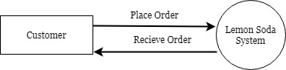

**Level 0 DFD**

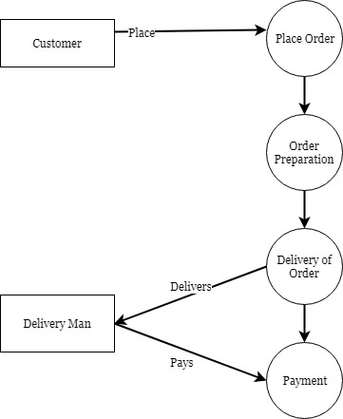

**Mechanism to Conduct Lab:**

Lab will be conducted via Adobe Connect.